Derrick Nemetchek

Game Design

Milestone 3 Update

I’ve started looking at FPS microgame this week, which is what I’ll be building my game off of. I can easily see the advantage of component based design patterns. Though the game is short, there are a lot of systems which will require time for me to unpack and learn in order to implement my own systems.

I’ve expanded more on the Trello, though I should be careful not to make it too big. I notice when I use these there’s a separation between design thinking and what I’m actually able to create at that point. 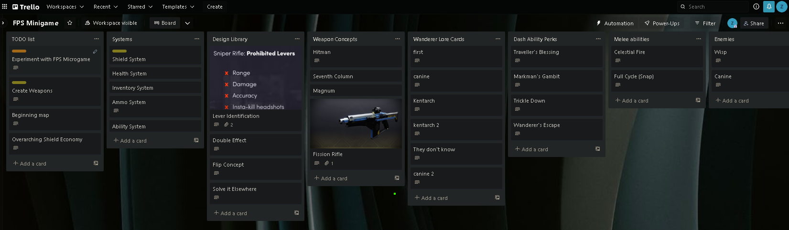

Pic of me editing UI

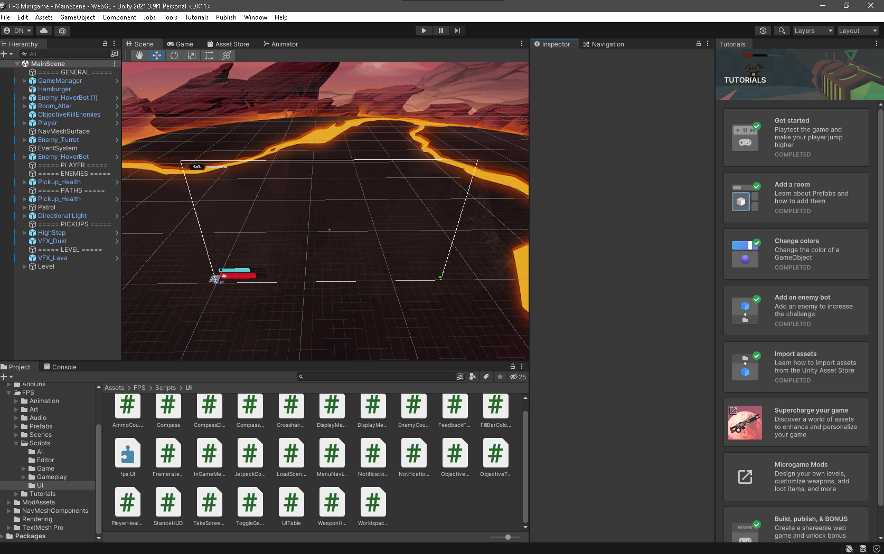

Pic of ingame gameplay. 